Instruction for doit firmware

Introduction
The shield is designed based on esp8266 by Espressif Systems, pin-compatible with Arduino UNO/Mega2560 DevBorad.
The serial wifi shield has the following features:
1.WiFi module is industrial-grade chips ESP8266, which is ESP-12E with metal shield, strong anti-interference ability;
2, Shield is pin-compatible with Arduino Uno, Mega2560 and other control board. A voltage converter chip is used to deal with 3.3V (Esp8266) and 5V (Arduino);
3, Dual DIP switches is used for serial ports so that this module shield can be used alone as an Arduino Uno expansion board, and also be used as ESP8266 expansion board;
4, Serial data is transported to WiFi device transparently, and vice versa. Arduino program does not need any configuration;
5, WebServer is developed to configure WiFi parameters and serial port parameters;
6, The module shield can be used as an independent ESP8266 development board. for instance, downloading the official AT commands firmware, NodeMCU open source firmware can be used;
7, The module shield also can be used as stand-alone expansion board for Arduino Uno.

Technical Specifications
- 802.11 b / g / n wireless standards;
- STA / AP modes support ;
- TCP / IP protocol stack, One socket;
- Supports standard TCP / UDP Server and Client;
- Supports serial port baud rate configuration: 1200/2400/4800/9600/19200/38400/57600/74800/115200 bps;
- Supports serial data bits: 5/6/7/8 bits;
- Supports serial parity: none;
- Supports serial stop bits: 1/2 bit;
- Pin-compatible with Arduino UNO, Mega;
- Arduino Pinout 2/3/4/5/6/7/8/9/10/11/12/13;
- ESP8266 GPIO Pinout 0/2/4/5/9/10/12/13/14/15/16 / ADC / EN / * UART TX / UART RX;
- KEY button: modes configuration;
- Dual-Ports DIP switches: switching Arduino and ESP8266;
- WiFi operation current: continuous transmission operation: ≈70mA (200mA MAX), idle mode: <200uA;
- Serial WiFi transmission rate: 110-460800bps;
- Temperature: -40℃ ~ + 125 ℃;
- Humidity: 10%-90% non-condensing;
- Weight: about 20g (0.7oz);

Dimensions

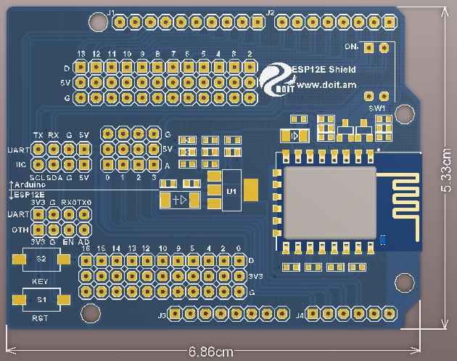

Interface Definition
This serial WiFi module board provides interface as shown in PCB view. And each pin functions are silk-printed in circuit board, as follows:
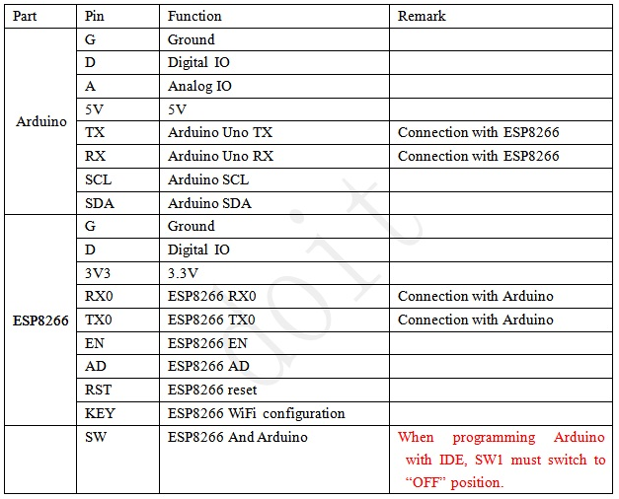
LED definition
ESP8266-Based serial WiFi Shield has two LEDs. Red color LED is donated to power supply. Blue LED is a multi-functional LED, and its function is described as follows:
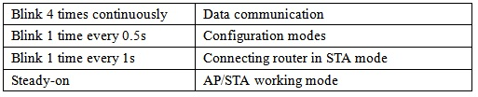
How to use this shield?
This section uses two examples to quickly configure ESP8266-Based serial WiFi shield, so as to achieve Serial WiFi transparent communication.

Preparation work: configuration WiFi working mode
For serial WiFi shield, the factory default working mode is configuration mode. Transparent communication configuration should be done firstly.
Attention: if the shiled has been configured to operate in other working mode, the module shield can enter configuration mode through the following ways. One is that press KEY button for more than 1 second. The other one is that send “!@!” to the serial WiFi shield through serial port.
Step 1: Power the serial WiFi shield, and find the WiFi signal. The SSID is "DoitWiFi_Config". The Password is "12345678."
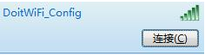
Step 2: Open the browser, and enter WiFi IP address: 192.168.4.1. The configuration page is shown as below.

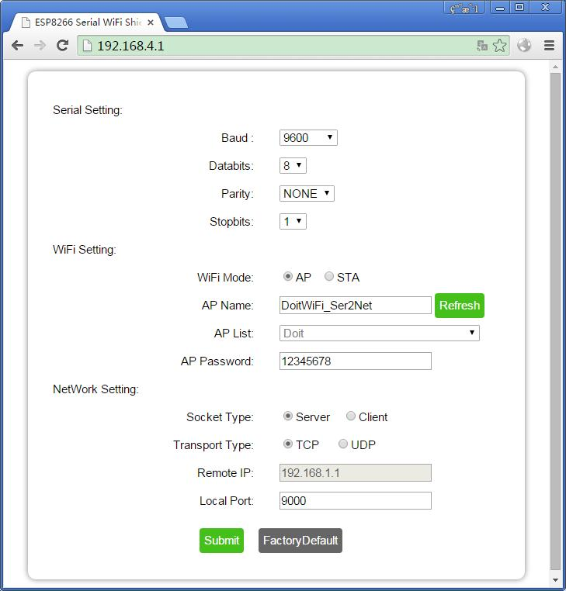
Built-in WebServer in the serial WiFi shield supports serial parameters configuration, network parameter configuration. And It also supports automatic or manual AP scan.

Step 3: press “submit”.
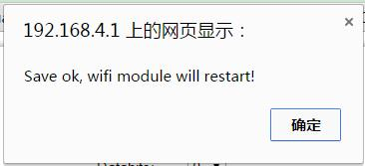

After submission, the serial wifi shield will automatically reboot into AP mode, and configure as:

The serial port parameters to 9600, n, 8, 1,

WiFi working mode: AP;

SSID: "DoitWiFi_Ser2Net";

Password: "12345678."

TCP Server, and port is 9000.

This is also the factory default configuration. You also can press "FactorDefault" to achieve the configuration as previously described.

Example 1: Arduino to WiFi communication

Step 1: plug the srial WiFi shield into the Arduino Uno board. The dual-ports DIP switch is switched to “OFF” position as to disconnect the serial port connection within ESP8266 and Arduino .

(Attention: when downloading arduino program with IDE, arduino serial port should NOT be used. Arduino Uno only has one serial port for downloading program, for the reason that the dual-port switches should switch to “OFF” position to disconnect the serial port of ESP8266. )

Step 2: program arduino Uno, and the example code is shown as below:
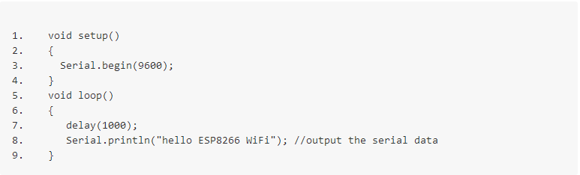
Step3: Switch the dual-port switch to “ON” position. Now, the ESP8266 is connected with Arduino Uno.
Step4: Find the WiFi signal “DoitWiFi_Ser2Net” with computer or mobile phone. The WiFi password is “12345678”.
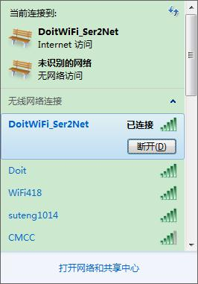
Step5: run the TCP/UDP Debugging software.
(Software Download Link: http://bbs.doit.am/forum.php?mod=viewthread&tid=174&page=1&extra=#pid206 )

Establish a TCP client connection, and the Destination IP address is 192.168.4.1, Port number is 9000.Local port is configured to “Auto”.
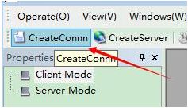
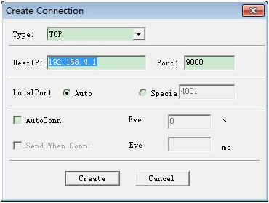
Once connection is build successfully, the software shows the transported data from serial WiFi shield every one second. Therefore, Arduino can send the serial data to the network.

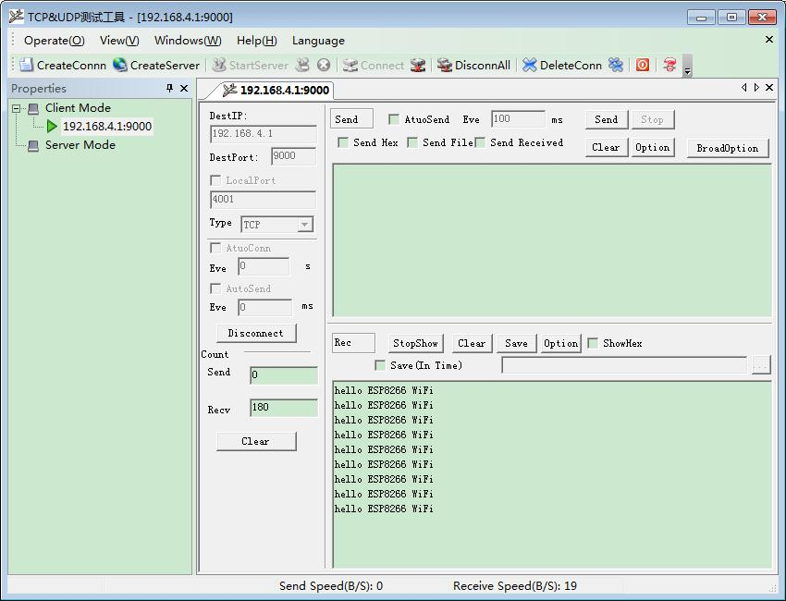

Example 2: communicate with remote server
Here, Doit free public WiFi network TCP tool is used to accomplish the example.

Step 1: Get a temporary IP address and port from the TCP server. Here, the obtained IP address is : “115.29.109.104”, and the port number is “6533”.
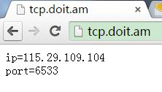
(Note: IP address and port number can be obtained in http://tcp.doit.am )
Step 2: enter the configuration mode. After powering the serial WiFi shield, press KEY button for more than one second. Connect the SSID named “DoitWiFi_Config” with the passward “12345678”. Then, enter "192.168.4.1" in the browser.
Step 3: Configure the serial WiFi shield to node mode (STA mode), so as to connect to a wireless router, as below:
“WiFi Mode”: STA;
Here a wireless router named “MIFI_A6_cd1c” is used and the password is “mifi66666666”.
WebServer will automatically refresh the current ESP8266 searched AP list when loading the page. When selecting "STA", "Refresh" button is enabled to refresh the WiFi scan results.
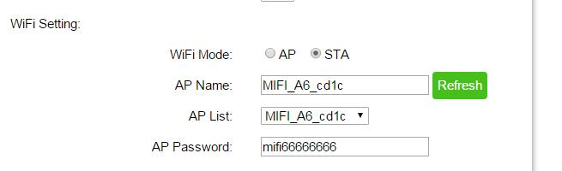
Step 4: Configure network parameters.
Socket Type： “Client”。
Transport Type： “TCP”。
Remote IP:“115.28.109.104”
Remote Port：“6533”。
Step 5: press “Submit”.
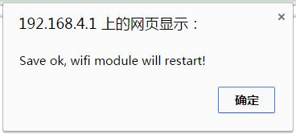
Step 6: run the TCP/UDP debug software. Establish a TCP Client connection. The destination IP address is 115.29.109.104, Port number is 6533. Local port is configured to “Auto”.
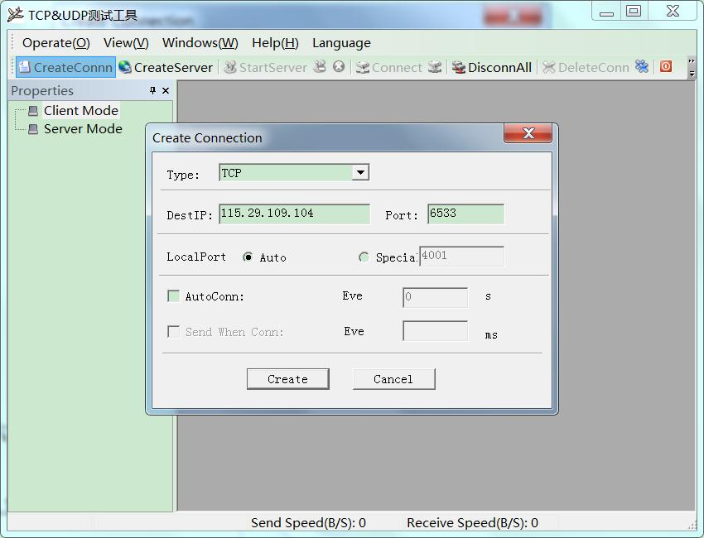

Step 7: the software shows the transported data from serial WiFi shield through the wireless router. Therefore, Arduino can send the serial data to the network in STA mode.
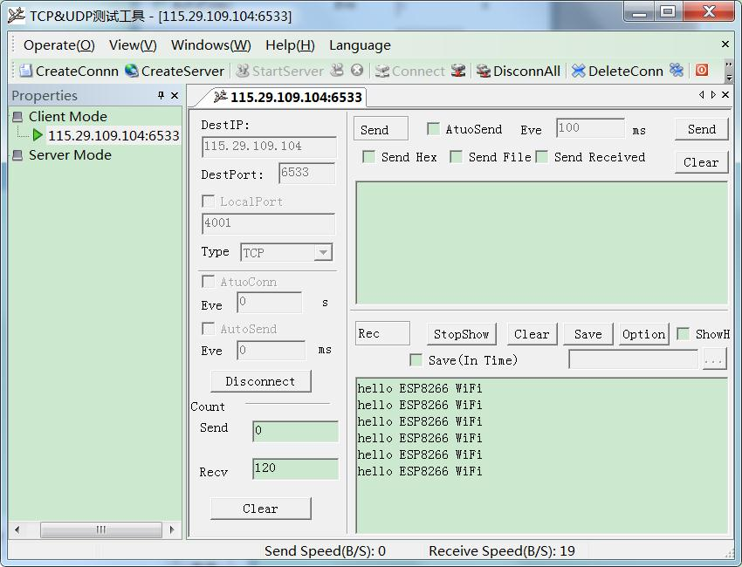

Working Mode Switch
Work process of the Serial WiFi shield is shown as below:
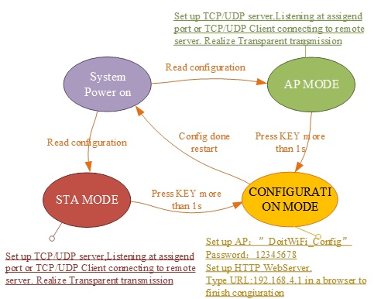
Serial Parameters Configuration
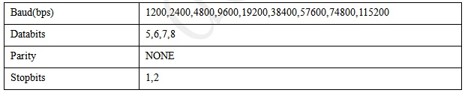WiFi Mode Configuration
The working mode of serial WiFi shield includes AP and STA modes. When AP mode is chosen in WebServer,“refresh” and “AP List” buttons will be abandoned. However, SSID and Password may be set.
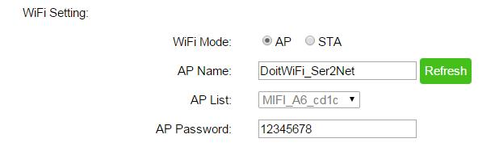
If STA mode is chosen, “refresh” and “AP List” buttons will be enabled. “Refresh” may be used to scan other WiFi signal, and the scanned result will be shown in the “AP List”.
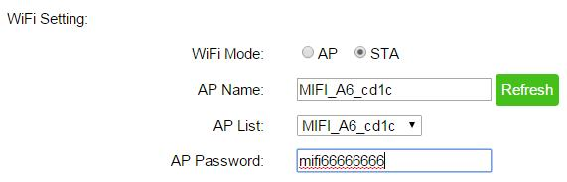
When the serial WiFi shield is in the STA mode, it will always try to connect the specified wireless router till the connection is built or configuration mode is set.
Network Settings
Network settings can be set as the server (Server) or the client (Client) mode. WiFi expansion module only supports a Socket at the same time.
When “Server” mode is set, "Remote IP" is abandoned. And the listening port number should be filled in "Local Port".
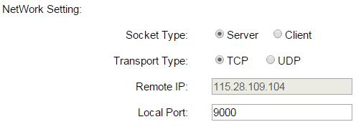

When “Client” mode is set, "Remote IP" is enabled. “Remote IP” and “Remote Port” should be filled in.
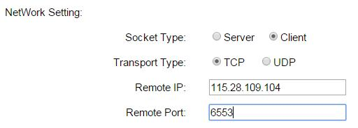
The Serial WiFi shield supports TCP and UDP wireless protocol.
Factory Default
In WebServer, “FactoryDefault” is used to reset to default settings. (If serial WiFi shield is in STA mode, please press KEY button to enter configuration mode.). The default setting is as below:
